Draw a labelled diagram on the Earth showing the crust, lithosphere, asthenosphere, mantle, inner core, outer core and atmosphere

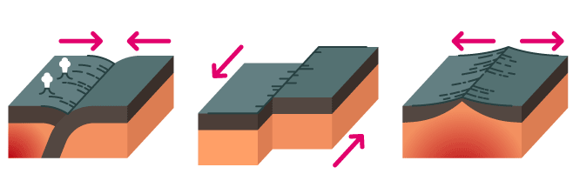
A
B
C

Identify the Plate boundaries shown in the image above:

A ____________________________________________

B ____________________________________________

C ____________________________________________

Complete the following table:
Layer or sphere | What is it? | Average thickness | Solid or liquid | What is it made up of?
Atmosphere
Lithosphere
Upper mantle
Lower mantle
Inner core
Outer core
Oceanic crust
Continental crust
Biosphere

Complete the following table:
Landform or activity | How is it formed/how does it occur? | What type of plates boundary is involved (if any)
Cinder Cone Volcano
Complex volcano
Composite/Strato-Volcano
Shield Volcano
Spatter Cone Volcano
Super Volcano
Earthquake
Tsunami
Mountain range
Mid-ocean ridge
Oceanic trench
Atoll
Geyser
Hot spring
Geothermal vent
Define the following terms:

Plate tectonics:

______________________________________________________________________________________________

______________________________________________________________________________________________

______________________________________________________________________________________________

Seismology:

______________________________________________________________________________________________

______________________________________________________________________________________________

______________________________________________________________________________________________

Geophysics:

______________________________________________________________________________________________

______________________________________________________________________________________________

______________________________________________________________________________________________

Seismograph:

______________________________________________________________________________________________

______________________________________________________________________________________________

______________________________________________________________________________________________

Richter Scale:

______________________________________________________________________________________________

______________________________________________________________________________________________

______________________________________________________________________________________________

Subduction:

______________________________________________________________________________________________

______________________________________________________________________________________________

______________________________________________________________________________________________

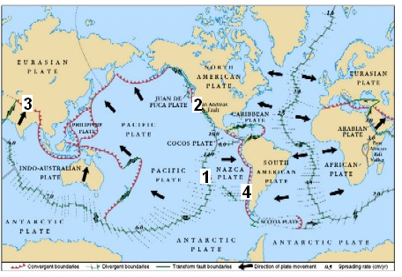

Identify the type of plate boundary that would be found at locations 1-4 on the map above:

1 _____________________________________________

2 _____________________________________________

3 _____________________________________________

4 _____________________________________________

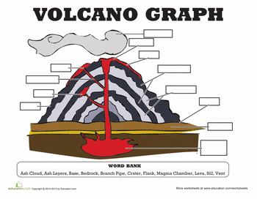

Label the diagram using the following words: ash cloud, ash layers, base, bedrock, branch pipe, flank, magma chamber, lava, still, vent

Explain how the following pieces of evidence support the theory of continental drift:

- Continents fitting together like a puzzle

- Same/similar fossils found on different landmasses

- Rock layers and mountains on coast lines matching up between land masses

- Evidence of glaciers in places with a hot or temperate climate

